ICARUS -
Roadmap and cross fertilisation with concurrent U-space projects
 | Deliverable ID: | D7.1
 | Dissemination Level: | CO
 | Project Acronym: | ICARUS
 | Grant: | 894593
 | Call: | H2020-SESAR-2019-2
 | Topic: | Common Altitude Reference
 | Consortium Coordinator: | e-GEOS
 | Edition Date: | 30 May 2021
 | Edition: | 00.01.00
 | Template Edition: | 02.00.02

EXPLORATORY RESEARCH

Authoring & Approval
Authors of the document
Name/Beneficiary | Position/Title | Date
Cristina Terpessi/ EGEOS | Project Coordinator
Manuel Onate/ EUROUSC ES | Communication and Dissemination Manager
Piotr Dybiec/DRONERADAR
Peter Hullah/EUROCONTROL
Francesco Russo/TOPV

Reviewers internal to the project
Name/Beneficiary | Position/Title | Date
Massimo Ianni / EGEOS | Steering Committee member
Andrea D’Agostino / TPZ | Steering Committee member
Costantino Senatore / EUSC IT | Steering Committee member
Pawel Korzec / DRAD | Steering Committee member
Lorenzo Rossi / POLIMI | Steering Committee member
Mattia Crespi / DICEA | Steering Committee member
Giancarlo Ferrara / ECTL | Steering Committee member
Andrew Hately/ECTL
Marilea Laviola / EUSC IT

Approved for submission to the SJU By - Representatives of beneficiaries involved in the project
Name/Beneficiary | Position/Title | Date
Cristina Terpessi/ EGEOS | Project Coordinator and Deliverable Leader
Manuel Onate/ EURSC | Communication and Dissemination Manager
Corrado Orsini/ TPZ | Technical Coordinator
Alberto Mennella/ TOPV | Technical Coordinator
Marco Nota/ TPZ | Consortium Board member
Wojciech Wozniak/ DRAD | Consortium Board member
Filippo Tomasello/ EUSC-IT | Consortium Board member
Mirko Reguzzoni/ Polimi | Consortium Board member
Mattia Crespi/ DICEA | Consortium Board member
Giancarlo Ferrara/ ECTL | Consortium Board member

Rejected By - Representatives of beneficiaries involved in the project
Name/Beneficiary | Position/Title | Date

Document History
Edition | Date | Status | Author | Justification
00.00.00 | 06/05/2021 | Draft | M. Onate/EUROUSC-Es | Structure of the document
00.00.01 | 20/05/2021 | Initial version | M. Onate/EUROUSC-Es | First draft
00.00.03 | 26/05/2021 | Draft version | M. Onate/EUROUSC-Es | Incorporate all feedback received
00.00.04 | 29/05/2021 | Revised version | P. Hullah/ EUROCONTROL | Final revised version
00.01.00 | 30/05/2021 | Final version | C. Terpessi/eGEOS | Final approved version

Copyright Statement
© – 2021 – ICARUS beneficiaries. All rights reserved. Licensed to the SESAR Joint Undertaking under conditions

ICARUS
Integrated Common Altitude Reference system for U-Space

This Project Management Plan is part of a project that has received funding from the SESAR Joint Undertaking under grant agreement No 894593 under European Union’s Horizon 2020 research and innovation programme.


Abstract
The present document is deliverable D7.1 “Roadmap and cross fertilisation with concurrent U-space projects” of the ICARUS project and is produced under Work Package 7 “Project Management”.
This document analyses the links existing with other projects dealing with the definition and demonstration of U-space services to ensure that the most effective use of resources is allocated, identifying gaps and reducing wasteful duplication of effort as much as possible.
This document has been written to provide participants of ICARUS with a guideline to potential links with other projects that can be useful for their work within the project.

Table of Contents

Abstract 4
Table of Contents 5
1 Introduction 7
1.1 Applicable Reference material 8
1.2 Acronyms 8
2 Methodology and objectives 11
2.1 Benefits of cross fertilization 11
2.2 Cross fertilisation method 12
3 Identification of past and concurrent projects 13
3.1 Past projects 13
3.2 Concurrent projects 13
3.3 Summary 16
4 Main findings of past projects 18
5 Concurrent projects 21
5.1 5G!Drones 21
5.2 Ampere 23
5.3 AMU-LED (Air Mobility Urban – Large Experimental Demonstrations) 24
5.4 BUBBLES 25
5.5 CORUS-XUAM (Concept of operations for European UTM systems – Extension for urban air mobility) 26
5.6 DACUS 27
5.7 Delorean 28
5.8 Labyrinth 29
5.9 Metropolis 2 29
5.10 GOF2.0 30
5.11 RADIUS (Railway digitalisation using drones) 31
5.12 SUGUS 32
6 Monitoring of projects 33
7 Other planned interactions 34

List of Tables

Table 1 – Acronyms list 9
Table 2 – Summary table 16

List of Figures

Figure 1 – The four benefits of cross-fertilisation 11
Figure 2 – Cross fertilisation method 12
Figure 3 - CORUS airspace volume classification: the environment for ICARUS use cases definition 19
Figure 4 - U-space services refined by CORUS final CONOPS and possible collocation of ICARUS altitude translation service 20
Figure 5 - Architecture of 5G!Drones environment 22
Figure 6 - Deployment of CARS system on 5G edge servers infrastructure 23
Figure 7 – AMU LED flight campaign locations 25
Figure 8 – Standardization and regulatory bodies roadmap 34

Introduction
The ICARUS project proposes an innovative solution to the challenge of a Common Altitude Reference System for unmanned aircraft (UA or drones) inside VLL airspace, with a GNSS altimetry-based approach and the definition of a geodetic-barometric transformation algorithm, implemented by a dedicated U-space service.
In manned aviation, the methods of determining the altitude of an aircraft are based on pressure altitude difference measurements (e.g. QFE, QNH and FL) with reference to a common datum. UA flights add a new challenge to this since a small drone may take off from and land almost anywhere, thus reducing the significance of QFE settings, that display altitude on the altimeters of manned aircraft relative to the local runway (whose elevation is, therefore, zero). In fact, the possibility for n drones to take off at n different places would generate a series of n different QFEs corresponding to different ground pressures altitudes with reference to the take-off “home points”. Therefore, for a large number of drones, new methodologies and procedures need to be put into place.
ICARUS proposes the use of GNSS receivers with suitable requirements for a common vertical UAS-UAS reference and the definition of a new U-space service (U3) for altitude conversions in a common UAS-Manned aircraft reference, tightly coupled with the interface of the existing U-space services (e.g. Tracking, and Flight Planning services). Finally, the terrain model information above the ellipsoid datum used in the GNSS receivers, including ground obstacle information, will also be an important element of the study. The users of the ICARUS service will be remote pilots who are competent to fly Specific-category VLOS or BVLOS UAS operations, ultralight and GA pilots who potentially share the same VLL airspace, and also the drone itself, when the increased level of automation and connectivity expected at U3 level are considered.

Applicable Reference material
- UAS ATM Common Altitude Reference System (CARS) https://www.eurocontrol.int/publication/uas-atm-common-altitude-reference-system-cars
- CORUS Project final CONOPS https://www.eurocontrol.int/project/concept-operations-european-utm-systems
- H2020 SJU BUBBLES project https://www.sesarju.eu/projects/bubbles
- DACUS Project https://www.sesarju.eu/projects/dacus
- AMU-LED Project https://amuledproject.eu/
- CORUS-XUAM Project https://corus-xuam.eu/about/
- LABYRINTH Project http://labyrinth2020.eu/
- METROPOLIS 2 Project: https://cordis.europa.eu/project/id/892928
- GOF 2 Project: https://gof2.eu/project/
- AMPERE Project https://www.gsa.europa.eu/asset-mapping-platform-emerging-countries-electrification
- DELOREAN Project https://www.gsa.europa.eu/drones-and-egnss-low-airspace-urban-mobility
- RADIUS Project https://projectradius.info
- 5G!drones Project https://5gdrones.eu
- SUGUS Project https://projectsugus.eu

Acronyms
Acronyms | Meaning
ATC | Air Traffic Control
ATM | Air Traffic Management
ATZ | Aerodrome Traffic Zone
BVLOS | Beyond Visual Line of Sight
DEM | Digital Elevation Model
DSM | Digital Surface Model
DTM | Digital Terrain Model
EASA | European Union Aviation Safety Agency
EGNOS | European Geostationary Navigation Overlay Service
EGNSS | European Global Navigation Satellite System
FL | Flight Level
GA | General Aviation
GBAS | Ground Based Augmentation System
GNSS | Global Navigation Satellite System
ICAO | International Civil Aviation Organization
ISA | International Standard Atmosphere
MCMF | Multi Constellation Multi Frequency
QFE | Query Field Elevation
QNH | Query: Nautical Height
RNP | Required Navigation Performance
SBAS | Satellite Based Augmentation System
SJU | SESAR Joint Undertaking
SORA | Specific Operations Risk Assessment
UA | Unmanned Aircraft
UAS | Unmanned Aerial
UAM | Urban Air Mobility
UTM | Unmanned Traffic Management
VLL | Very-Low-Level
VLOS | Visual Line Of Sight
VTOL | Vertical Take Off and Landing
Table 1 – List of acronyms

Methodology and objectives

Benefits of cross fertilization
Research should not take place in isolation. Innovation is all about exploring new possibilities, outside of preconceived ideas. Successful business ecosystems are characterised by the free interchange of ideas between different actors that translate into new products and services, sometimes discovering derivative applications that were not even considered by the creators of the original technologies.
The most obvious benefit of cross fertilisation is the identification of redundant areas of research that are being actively pursued by other projects, thus ensuring the most effective use of resources is allocated, reducing wasteful duplication of efforts as much as possible.
But there are other direct benefits of the cross-fertilisation efforts, as shown on the following diagram:

Figure 1 – The four benefits of cross-fertilisation
These benefits are:
- Optimisation of resources: As mentioned above, cross-fertilisation ensures that resources are not wasted pursuing results that are already available or will become available in the future.
- Specify and refine requirements: Other projects could potentially benefit from the ICARUS services and, in return, can provide valuable information to identify requirements that have to be fulfilled for these services to use the relevant ICARUS services.
- Validate the approach: Other projects can be considered “use cases” or “early users” of the ICARUS services that complement the validation exercises that will be carried out as part of the ICARUS study.
- Cross-promotion: Interaction with other projects provides access to reach other audiences that are not the primary focus of ICARUS and thus increase the outreach of the project.

Cross fertilisation method
To achieve these benefits, the methodology shown in the figure below will be used:
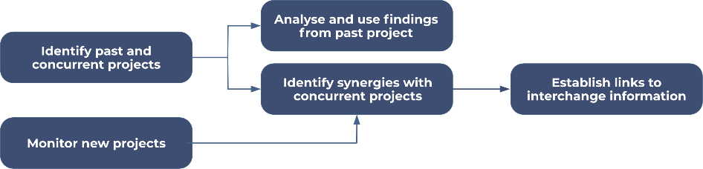
Figure 2 – Cross fertilisation method
  - Identify past and concurrent projects: The first step is to identify which projects are more interesting to our study in terms of the four potential benefits described in the previous section.
  - In the case of projects that have already finished it will not be possible to influence them to consider or incorporate our research (thus the validation and cross-promotion benefits are not possible) but they have the advantage that their findings are published and can be analysed to be considered as input by ICARUS.
  - In the case of concurrent projects, their objectives and proposed methodologies can be analysed to identify the most promising synergies that can be obtained through cooperating with them.
  - Once these synergies have been determined, it will be possible to establish appropriate links with them for interchanging information.
  - The process of discovery of potentially useful projects should be maintained during the whole lifetime of the project as new projects can be started after the initial analysis.

Identification of past and concurrent projects

Past projects
ICARUS will exploit the outcomes of past U-space exploratory research projects, considering their findings and recommendations, as well as the lesson learned from them.
The following documents and projects have been considered by ICARUS:
- UAS ATM Common Altitude Reference System (CARS): This study is one of a collection of three documents discussing the issues raised in the first UAS-ATM Integration Workshop held in April 2017 and a series of webinars organised in the first half of 2018 to enable interested stakeholders to express their points of view. The document is a proposal of guidelines on establishing a common altitude reference system, part of a joint approach between EUROCONTROL and EASA to developing a UAS Integration manual and the joint EUROCONTROL/EASA UAS ATM Operational Concept document. It was unfortunately too late to be taken into account in the Concept of Operations produced by the on-going CORUS project (see below).

- CORUS project final CONOPS: The Concept of Operations for European Unmanned Traffic Management (UTM) Systems (CORUS) project encompassed two years of exploratory research to adopt a harmonised approach to integrating drones into very low-level (VLL) airspace.

- SJU Exploratory Research projects 2016: The exploratory research projects produced a list of requirements that have been considered for the definition of the ICARUS architecture.

- U-space 2019 Demonstrators: The outcomes of SJU U-space Very Large-Scale demonstrators will be especially considered during the validation stage of the ICARUS concept.

Concurrent projects
ICARUS can be seen as a fundamental element in defining the Common altitude reference that other services can be built on top of. As an example, other concurrent SJU initiatives, such as the DACUS and BUBBLES projects, will be continuously monitored for cross fertilisation and harmonisation activities, considering the main objectives of these projects that are tightly coupled to ICARUS. In particular:
- BUBBLES aims at defining separation minima and methods for unmanned air systems (UAS) flying in very low-level airspace (VLL), to improve the overall performance and safety therein.

- DACUS aims to develop a service-oriented demand and capacity balancing (DCB) process for drone traffic management. This overall objective responds to an operational and technical need in European drone operations for a tangible solution integrating the functionalities of the SESAR U-space services for traffic management to produce timely, efficient and safe decisions.

There are other projects funded by SJU in the context of U-space that are of interest to ICARUS, such as:

- AMU-LED will test real UAM operation in a U-space ecosystem for coordinated flights of several types of UAVs in different scenarios, use cases and applications (e.g. air taxis, emergency services, delivery of goods, surveys, etc.) for surveillance, logistics and mobility using air vehicles. Some of these use cases are similar to those considered in ICARUS, thus providing excellent validation data.

- CORUS-XUAM is a two-year very large-scale demonstration (VLD) project that will demonstrate how U-space services and solutions could support integrated Urban Air Mobility (UAM) flight operations. The activities will start with updating the U-space Concept of Operations to address the integration of UAM/UAS operations into the airspace and identifying new U3/U4 services.

- Labyrinth will contribute to a safer, more efficient and sustainable civil road, rail, air and waterborne transport with new centralised planification systems capable of communicating with all the drones in a certain area, processing their desired origin and destination points and computing paths that avoid collisions.

- Metropolis 2 will provide the fundamentals for concrete solutions for U-space U3/U4 services that are needed to enable high-density urban aerial operations, with a unified approach to the following U-space services: strategic deconfliction, tactical deconfliction, and dynamic capacity management,

- The GOF2.0 very large demonstration project will safely, securely, and sustainably demonstrate operational validity of serving combined UAS, VTOL and manned operations in a unified, dense urban airspace using current ATM and U-space services and systems.

Other initiatives and projects (not only funded by SJU) will be considered during the lifetime of the project. In particular the following projects have been identified:

GSA projects

The European Global Navigation Satellite Systems Agency has funded several application projects fostering the use of Galileo and EGNOS. Some of these concurrent studies in both aviation, U-space and drone domain will be taken into account during the life cycle of the ICARUS project so that Consortium members are always updated about Galileo and EGNOS added value and differentiators for GNSS based altimetry. Three projects have been identified for monitoring:

- H2020 Ampere project: Drones for electric infrastructures monitoring

- H2020 Delorean Project: Drones with EGNSS Receivers in Urban VLL airspaces in the context of Urban Air Mobility

- H2020 Radius Project: Railway digital transformation using drones

Direct contact will be established with these projects’ coordinators by the ICARUS coordinator or Consortium members. It is understood by the consortium that other projects of particular interest for ICARUS may eventually start, therefore a direct contact with GSA will be established by the ICARUS technical coordinator, who will also make them aware of the

Other EC funded projects

Other projects funded directly by the EC under the H2020 programme will be considered for cross fertilisation and mutual interaction. In particular the following projects have been identified at this stage:

- H2020 5G!drones: 5G technology in support of drone operations through different use cases.

- SUGUS project: accelerating the use of the European GNSS (EGNOS and Galileo) in the UAS market.

Monitoring new projects
Other projects and initiatives of a particular interest for the project can also be identified during ICARUS implementation (see section 6).

Summary
The following table summarises the main projects and documents considered for cross fertilisation with the ICARUS project.
Project name | Status | Relation to ICARUS | Link
5G!drones | Concurrent | Could potentially provide 5G mobile networks as a service enabler for UAS and various supplementary services, among them for CARS. | DroneRadar Sp. z o.o. is participating in both projects
Ampere | Concurrent | Added value of MCDF Galileo Receiver installed on drones for BVLOS operations, Ground obstacle and Terrain Model awareness | TopView SRL is participating in both projects
AMU-LED | Concurrent | AMU-LED will perform Urban Air Mobility demonstrations that constitute clear use cases for the ICARUS services. | AMU-LED is represented in the ICARUS Advisory Board
BUBBLES | Concurrent | BUBBLES could potentially integrate the ICARUS services in their algorithms to improve their separation minima criteria. | Bubbles is represented in the ICARUS Advisory Board
CARS | Finished | The CARS document constitutes a foundation basis for ICARUS. | EUROCONTROL published the document.
CORUS | Finished | The CORUS CONOPS is being used by ICARUS, especially with respect to VLL airspace classification and U-space service classification. | EUROCONTROL participated in the project.
CORUS-XUAM | Concurrent | CORUS-XUAM is an VLD (Very Large Demonstration) SESAR JU Project. CORUS-XUAM demonstrations can help to validate the ICARUS concept. | EUROCONTROL is participating in both projects
DACUS | Concurrent | The ICARUS U-space service will be an essential element in providing safe separation and ensuring that such separation does not compromise avoidance of obstacles on the ground. | DACUS is represented in the ICARUS Advisory Board.
DELOREAN | Concurrent | Validation report in the urban environment about the performance of EGNSS receivers in presence of strong multipath, scattering or interference. | To be established
LABYRINTH | Concurrent | LABYRINTH will manage drone swarms. ICARUS would be very useful in ensuring vertical separation of these drones. | To be established
METROPOLIS | Concurrent | Integration of ICARUS into their validation demonstration would be mutually beneficial. | To be established
GOF2.0 | Concurrent | GOF20 is an VLD (Very Large Demonstration) SESAR JU Project. GOF2.0 flights can be used as a testbed for the ICARUS concept. | DroneRadar Sp. z o.o. is participating in both projects
RADIUS | Concurrent | RADIUS will investigate an EGNSS-based augmented positioning system to navigate in a complex railway environment, providing useful information about the EGNOS Open Service capabilities and performance. | EuroUSC is participating in both projects
SUGUS | Concurrent | SUGUS is implementing an API for EGNSS services which could be used by the ICARUS services. | SUGUS is represented in the ICARUS Advisory Board.

Table 2 – Summary of the main projects considered

Main findings of past projects
The following documents and outcomes have been considered as input for the ICARUS project:
- UAS ATM Common Altitude Reference System (CARS): This study published by EUROCONTROL in 2019 is one of the main inputs for the ICARUS project. To maintain separation between all users of this airspace, it is essential that the altitudes of all of these aircraft be known unambiguously. However, whereas conventional manned aviation uses pressure altitude obtained from barometric readings, UAS often use other systems such as satellite-derived altitudes. While each of these different systems can enable safe separation on its own, they can each furnish different altitude values from each other. A common altitude reference system needs to be established. This document provides a basis for discussion on such a system, following a workshop and a series of webinars organised by EUROCONTROL in collaboration with the European Aviation Safety Agency (EASA). The study concludes with 3 options:

  - Option 1: barometric measurements for all operations at VLL, no U-space services;
  - Option 2: GNSS measurements for all operations at VLL, no U-space services;
  - Option 3: Mixed approach; each airspace users will use its approved altimetry system, U-space services will be used for translation.

ICARUS follows up on the CARS study, starting from option 3, with the focus on GNSS altimetry requirements for a common UAS-UAS vertical reference, a UAS-manned aircraft translation service, and ground obstacle information provided to UAS by U-space services.
- CORUS project final CONOPS: The Concept of Operations for European Unmanned Traffic Management (UTM) Systems (CORUS) project encompassed two years of exploratory research to adopt a harmonised approach to integrating drones into very low-level (VLL) airspace. CORUS outcomes provide another important starting point for the ICARUS project. In particular, in CORUS it is recognised that small drones commonly use altitudes based on GNSS for practical and cost reasons, while existing aviation makes use of barometric altitudes. As the CORUS CONOPS was being written, work on the UAS ATM Common Altitude Reference System was ongoing, therefore the problem was taken into account in the study, but not investigated in detail. However, the project recognised that a GNSS-based approach for vertical separation of UAS from the ground requires a calculation of the height above ground, possibly achieved by a look-up table (or map), to give the height of the ground at the current location relative to the same ellipsoid. Such look-up tables trade-off accuracy against size, and potentially cost. Moreover, the project assumed that this ground-level calculation is performed inside the UAS (vehicle + remote piloting station), however the accuracy may vary.

ICARUS will take the CORUS final CONOPS into account, not only for following up the investigation about CARS, but also for using the outcomes of the project about:
  - New Airspace classification (X,Y, Z_{a},Z_{u}) to be used in ICARUS for the definition of the Use cases;
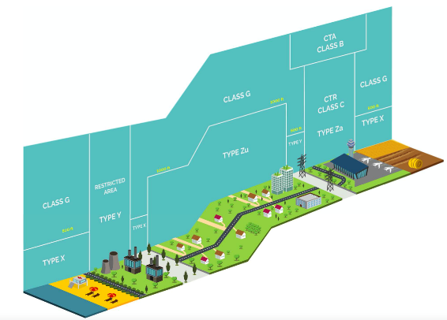
Figure 3 - CORUS airspace volume classification: the environment for ICARUS use cases definition
  - U-space service classification (updated version with respect to the initial SJU Blueprint). In particular the new added services will be considered in ICARUS as existing services with their own interfaces and high-level definition. The services listed hereafter will be helpful for a harmonised integration of the altitude translation service (offered by ICARUS). A possible collocation of the service will be proposed in the overall list of U-space services, as well as possible interactions with other U-space services needed to provide input data to feed the Altitude translation service.
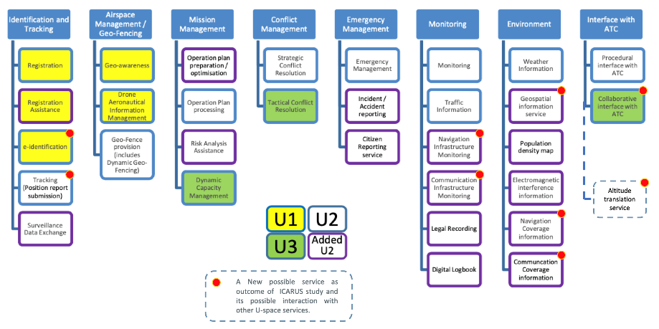
Figure 4 - U-space services refined by CORUS final CONOPS and possible collocation of ICARUS altitude translation service

- SJU Exploratory Research projects 2016: The exploratory research projects focusing on different aspects of the U-space ecosystem (with both a “top-down” and a “bottom-up” approach), produced a list of requirements with particular reference to the following excel files (available for the ICARUS consortium on the STELLAR platform):

  - PROJECT U-space requirements ER4 update (based on B3).xlsx
  - U-space requirements_Baseline3 (1_1).xlsx

The list of requirements produced in these previous studies have been analysed to identify the initial requirements applicable to the ICARUS project, with respect to the main objectives of the project.
- U-space 2019 Demonstrators: The main outcomes of SJU U-space Very Large-Scale demonstrators will be considered especially during the validation stage of the ICARUS concept, in terms of “lesson learned”. The projects that will be considered are mainly the DIODE and GOF projects due to the direct or indirect involvement of many ICARUS consortium partners.

Concurrent projects

5G!Drones
5G!Drones project was started on 1st June 2019 and is scheduled to last for 42 months. As mentioned in its objective statement, the ultimate goal of the project is “to design, implement and run trials of UAV use cases on top of a 5G infrastructure provided by ICT-17 and other complementary facilities, addressing contemporary 5G challenges”.
There are several specific use cases defined to verify and validate applications of 5G network services and capabilities to support execution of complex UAS service scenarios. Those use cases are designed to utilise new capabilities of the 5G networks: simultaneous usage, by means of Network Slicing, of eMBB (e.g. for high definition video streaming/transmission), URLLC (for UAS C2 communication) and mMTC (e.g. as a part of IoT infrastructure) services as well as computing power provided by edge servers and to prove that 5G networks can fulfil demanding UAS KPIs (like low-latency of C2 transmission, network signal quality and coverage guarantee, high bandwidth, massive number of connections/users) and thus can provide guarantee of high reliability services.
To fulfil the project’s objectives, the 5G!Drones consortium has designed a reference architecture of so called Trial Controller system, which allows the UAS mission over the 5G network facility to be defined, validated, deployed and managed.
The high-level, conceptual model of the Trial Controller solution is shown in Figure 8. In this diagram, the UA vertical is the main user of the system, and - through the Trial Controller - prepares the description of the trial. The entry point to the system, the Trial Controller’s web portal, allows the low level details of the underlying infrastructure to be abstracted, by providing an intuitive and user friendly interface, to allow the UA vehicles to describe the trial scenario. The trial scenario consists of a mission plan and the definition of the network and computing resources needed. Each trial consists of running one or two Network Slices (one uRLLC for relying C2 communication and eMBB or mMTC depending on the UAS use case specific needs). As underlying facilities vary, different slice templates are used – an Abstraction Layer hides the complexities and differences between these facilities. A typical trial process supported by the Trial Controller consists of a few stages: trial definition phase, trial validation phase (separately for the mission validation at U-Space level and facility level), deployment phase, mission execution phase and post-processing phase.
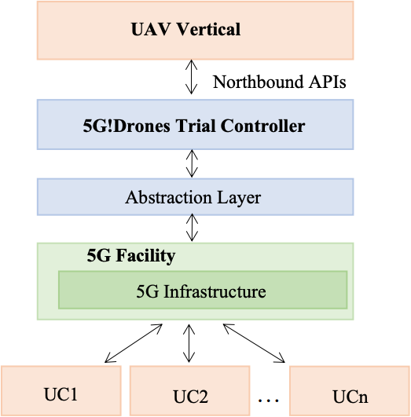
Figure 5 - Architecture of 5G!Drones environment
Different use cases (UC1, UC2, etc.) defined within the 5G!Drones project rely extensively on the edge computing capabilities of 5G facilities (MEC serves, cloud edge servers, etc). These edge servers will be used to host different applications supporting UAS mission execution. the majority of BVLOS-based use case scenarios will use GCS (UAS ground control station) in the form of a virtual server/dedicated application container hosted in such an edge server. Also, other data processing applications that receive streams of data from UAS, will be deployed as modules hosted in edge servers.
It is important to recognise, that mobile edge server infrastructure is highly distributed and “regionalised”: particular edge servers serve only local, neighbouring zones/cells.
This specificity of a mobile edge server infrastructure might be directly applied to the regionalised ICARUS system architecture foreseen.
Based on this conclusion we see a great opportunity for convergence between the two projects. Our aim should be to design and prototype the initial concept of the CARS system deployed as a distributed solution over the 5G edge servers, which can actually be trialled alongside the 5G!Drones trials.
An example architecture of such a deployment is provided in Figure 9.
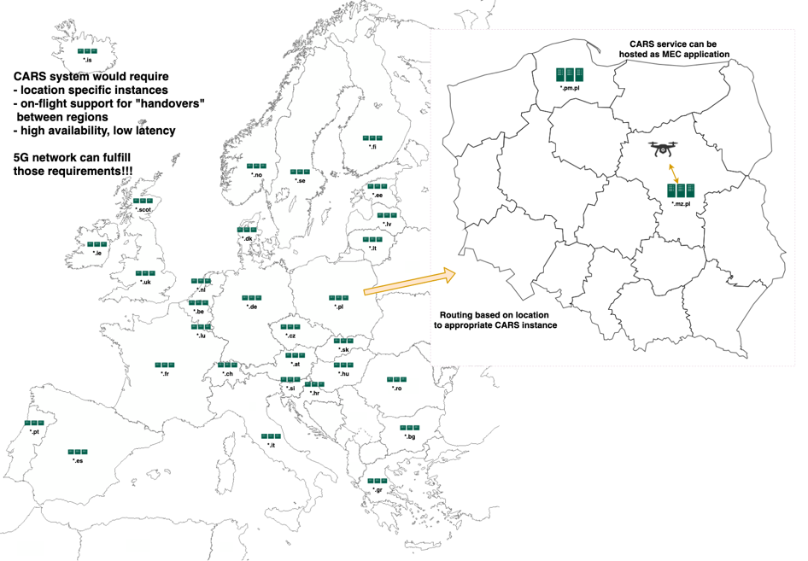
Figure 6 - Deployment of CARS system on 5G edge servers infrastructure
Moreover, the 5G infrastructure can fulfil and support CARS service to the greatest extent by:
- Providing the edge computing concept (local applications’ instances with the lowest latency guaranteed)
- Providing potential MEC application handover support (including users’ contexts) for UAS hovering across different areas/zones

Ampere
The purpose of the AMPERE (Asset Mapping Platform for Emerging countRies Electrification) project is to engineer and to start to commercialise a dedicated solution, to be used for electrical power network information gathering. AMPERE will support decision-making actors (e.g. institutions and public/ private companies in charge of managing electrical networks) to collect all required information for planning electrical network maintenance and upgrades.
In particular, the need for such a solution comes in emerging countries where access to electricity is still far from reliable. Indeed, the challenge facing such communities goes beyond the lack of infrastructure assets: what is needed is for poorly documented deployed infrastructure to be mapped so that a holistic assessment of energy demand and its expected growth over time may be undertaken.
AMPERE proposes a solution based on a GIS cloud-mapping technology, collecting field data acquired with optical/thermal cameras and LIDAR installed on board an unmanned aircraft (UA). In particular, a UA will be able to fly over selected areas performing semi-automated operations, even in BVLOS conditions, to collect optical and thermal images as well as 3D LiDAR-based reconstruction products.
The ideal use case of AMPERE is powerline inspection where the drone has no other concurrent traffic.
ICARUS project outcomes could support the AMPERE project’s mission planning both for other air traffic and for ground obstacle awareness in BVLOS conditions.
Moreover, the relationship with ICARUS is a solid one, given the similarities between AMPERE and the power-line inspection use case proposed in our project (see D3.1 - ICARUS Concept Definition: State-Of-The-Art, Requirements, Gap Analysis).
AMPERE could benefit from ICARUS:
- Altitude translation service: the common altitude reference system can solve conflictual problems in cases of multiple operations in the interested area. This is also useful for other technical aerial interventions (i.e. helicopters for other kinds of inspection in the same area) or leisure GA traffic that may be present in the area, using barometric reference (e.g. QNH).
- Digital terrain and obstacle map: electric pylons can be up to 100m high. For power line inspection, the obstacle map must report at least the position and height (AGL) of towers and cables. A digital model of the terrain and obstacles would be provided to the operator to allow a safe path to be determined to prevent collisions.
On the other hand, ICARUS can derive actionable insights by comparing the AMPERE results with ICARUS use cases to improve the accuracy of both altitude translation and digital terrain model services.

AMU-LED (Air Mobility Urban – Large Experimental Demonstrations)
AMU-LED will test real UAM operations in a U-space eco-system for coordinated flights of several types of UAV in different scenarios, use cases and applications (e.g. air taxis, emergency services, delivery of goods, surveys, etc.) for surveillance, logistics and mobility using air vehicles. At the end of the project, it will be demonstrated that any city or urban region (e.g. densly populated areas) may have the capability of offering UAM services and infrastructure taking its specificities into account in a standardised and safe form. Finally, this project will contribute significantly to defining the needs and features of on-board equipment for Urban Air Vehicles (UAV) . A set of experiments will be performed in three counties in Europe (the UK, Spain and the Netherlands), testing the drone platform itself and also the relevant U-space services to be deployed. The UAM eco-system needs to be holistically considered as a system of systems.
The flight demonstrations will accumulate more than 100 hours and flights will be performed across Europe in three different countries and various scenarios:
- United Kingdom (Cranfield) – June 2022, the first test campaign will test all developed technologies such as U-Space architectures, ATM/UTM integration and U-Space U1-U3 services in a fully controlled and complete sandbox environment.
- The Netherlands (Amsterdam / Rotterdam) – August 2022, the second flight campaign will take place in the Netherlands and will make use of three locations to showcase the safe integration of U-space in different urban environments. The campaign in the Netherlands will demonstrate operational procedures to interface with ATC via U-space, engage and deconflict between two drones (pre-flight and in-flight), and deal with flyability and urban canyon issues.
- Spain (Santiago de Compostela) – A demonstration in September 2022, carried out in Santiago de Compostela, will test CIS and U-space services deployed in the area to coordinate manned and unmanned traffic employing an architecture where a tracking service is not provided by USSPs but is a common service. The demonstration will address safe UAM flight and navigation, especially in complex urban environments.
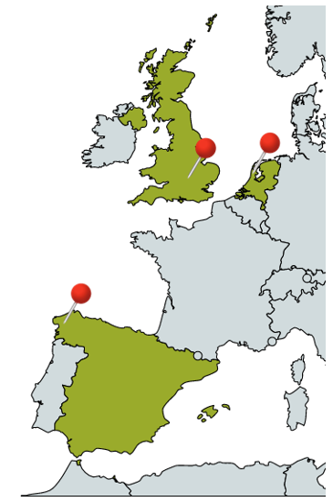
Figure 7 – AMU LED flight campaign locations

BUBBLES
The BUBBLES project aims at defining separation minima and methods for unmanned air systems (UAS) flying in very low-level airspace (VLL), to improve the overall performance and safety therein. BUBBLES will follow an operation-centred, risk-based approach, assigning the separation minima and methods within the framework of the U-space Concept of Operation (ConOps) and the corresponding risk level assessed using standard methodologies like specific operations risk assessment (SORA).
The project will also develop algorithms to compute the collision probability between drones, and between them and manned aircraft operating in VLL airspace, using separation minima to keep it within acceptable levels. Moreover, the project will investigate how artificial intelligence (AI) can contribute to dynamically managing these minima using different separation methods and agents (from ground-based strategic conflict resolution to distributed self-separation). The mitigation effect of U-space services will also be taken into account, as well as the external and system induced risks (including those derived from the use of AI). Finally, BUBBLES will extend the concept of performance-based Communications, Navigation and Surveillance (CNS) to the drone operations to draft safety and performance requirements and will develop monitoring tools to ensure that their actual performance complies with them.
BUBBLES will develop Artificial Intelligence (AI)-based algorithms to compute the collision risk of UAS, leading to separation minima and methods so that a Target Level of Safety (TLS) stated in terms of overall probability of collision can be defined and maintained.
These algorithms will be applied to a set of generic ConOps for UAS operations defined by BUBBLES, detailed enough to cover most of the applications envisaged, but generic enough not to be linked to any particular one. They will be classified in terms of risk using the SORA methodology.
These separation minima and methods will be assigned to the ConOps using AI techniques, leading to the definition of a set of generic Operational Service and Environment Definitions (OSED) from which safety and performance requirements for the CNS systems will be derived applying a performance-based approach.
Relation with ICARUS
BUBBLES can incorporate the findings of ICARUS to improve their separation criteria, taking into consideration the information provided by the ICARUS services during the tactical phase.

CORUS-XUAM (Concept of operations for European UTM systems – Extension for urban air mobility)
CORUS-XUAM is a two-year very large-scale demonstration (VLD) project that will demonstrate how U-space services and solutions could support integrated Urban Air Mobility (UAM) flight operations. These services should allow electric vertical take-off and landing vehicles (eVTOL), unmanned aircraft systems (UAS) and other airspace users (unmanned and manned) to operate safely, securely, sustainably, and efficiently in a controlled and fully integrated airspace, without undue impact on operations currently managed by ATM.
The activities will start with updating the U-space Concept of Operations to address the integration of UAM/UAS operations into the airspace and identifying new U3/U4 services. This will be followed by the preparation and execution of six challenging demonstration campaigns in Belgium, France, Germany/UK, Italy, Spain, and Sweden.
U-space and the integration of UAM into low-level airspace will undergo rapid research, innovation and implementation in the short and medium terms. Europe intends to be at the forefront of developing early solutions to support this fast-growing industry. A harmonised approach is essential.
UAM will enable on-demand, highly automated, passenger or cargo-carrying air transport services especially in urban and sub-urban environments, using electric vertical take-off and landing (eVTOL) aircraft together with new concepts, technologies, airspace management constructs/procedures, and regulations. New stakeholders will perform sustainable operations that are interoperable with manned and unmanned aviation as well as with current ATM operations.
The UAM challenges can only be met through an evolutionary development process ensuring the definition of appropriate, advanced, and interoperable U-space infrastructure, technologies, traffic management capabilities and new set of advanced services that fit with the expected types of operation and levels of demand.
The project aims to highlight the importance of U-space solutions for integrated operations that require mutual situational awareness of traffic. It will demonstrate integrated operations of both manned and unmanned aircraft employing advanced U-space services and will explore ways to facilitate a proper interface with ATM/ANS (air navigation services), with a particular focus on airport operations.
This will support the European Commission’s vision for the safe, secure, integrated, and efficient handling of drone and UAM traffic operations and will be a key enabler for the growing drone market to generate economic and social benefits.
Relation with ICARUS
CORUS-XUAM is providing a ConOps for UAM. Six VLDs will take place to validate this. ICARUS should be incorporated into these demonstrations to provide separation from other aircraft and from ground obstacles.

DACUS
A large number of UA operations in low-level airspace can increase air and ground risks, affect social acceptance and have a notable impact on the environment. To ensure safe and efficient UA traffic flows in this context, DACUS is developing a consistent demand and capacity balancing service for U-space that will consider the uncertainty of planned operations and a diverse set of external influencing factors, from the strategic to the tactical phase, to forecast traffic volumes and determine constraining measures in a timely manner.
Extensive research into influencing factors (e.g. CNS performance and availability), definitions (e.g. airspace structure), processes (e.g. separation management), and services (e.g. strategic and tactical conflict resolution) will lead to a highly automated and harmonised traffic management system.
A DACUS Performance Framework tailored to drone operations, that includes capacity, safety and environmental indicators will be defined, including the development of metrics for airspace capacity appropriate for an environment with no human controllers. This will address the Dynamic Capacity Management, Mission Planning Management, Flight Planning Management, Micro-weather, Strategic De-confliction and Tactical De-confliction U-space services. Innovative service algorithms, and enabling models and technologies, developed as functional blocks of the DCB process, will enable efficient and safe drone trajectories to be designed and managed, to support large numbers of simultaneous operations.
A very low-level (VLL) airspace structure and a set of airspace rules that optimise capacity while maintaining safety will be proposed that will define where separation will be procedural and where it will be tactical. An optimal balance will be sought between using on-board separation and a tactical U-space separation service, depending on the type of airspace, type of separation (drone-drone or drone-manned aviation), CNS performance, etc. Examination of boundary conditions, including public acceptance, business and regulatory aspects, for an urban environment will allow unambiguous requirements for the development of associated U-space services.
Communication, Navigation and Surveillance (CNS) requirements will be refined in support of tactical and procedural separation, with a focus on the urban environment. Changes with regard to current drone CNS references, will be substantiated through simulations.
Relation with ICARUS
DACUS is all about increasing capacity while ensuring safe separation. It includes automated, “on-board” separation and using the tactical U-space separation service. The ICARUS U-space service will be an essential element in providing this safe separation and ensuring that such separation does not compromise avoidance of obstacles on the ground. ICARUS should propose that DACUS use its service during their simulation activities.

Delorean
The DELOREAN project, funded by the GSA, will develop innovative EGNOS-based solutions for the increased mobility needs of people and goods, UAM (Urban Air Mobility) and UAD (Urban Air Delivery), in difficult urban scenarios. It will demonstrate the benefits that both of these services would bring to society by offering more immediacy to people’s needs, and providing real alternatives to traffic congestion. Live trials will be performed in the city of Benidorm, using EGNSS and intelligent systems for safe navigation inside the city’s challenging urban scenario.
Two CONOPS (Concept of Operations) are being defined, one for each type of service, and the Urban Lab, where all the necessary regulatory and technological documentation is collected and the scenarios are outlined, is being specified. Real urban scenarios will then be able to be fully designed and ready to be flown by drones.
The Delorean consortium will test, evaluate and quantify how distinguishing features of EGNOS and Galileo can contribute to the positioning and integrity requirements of such air services.
Relation with ICARUS
While Delorean will examine how EGNOS and Galileo can contribute to the positioning and integrity requirements, ICARUS will use GNSS for providing a common altitude reference. The two projects are, therefore, a perfect fit. Additionally, the urban environment used by Delorean, Benidorm, is very challenging and the ICARUS U-space service can be of great use providing avoidance of obstacles on the ground. ICARUS should propose integration of its service into their Urban Lab.

Labyrinth
Labyrinth will produce new centralised planning systems capable of communicating with all drones in a certain area, processing their desired origin and destination points and computing paths to avoid collisions. Labyrinth services will be offered to public or private entities responsible for managing land, sea, and air transport infrastructures, as well as emergency and rescue operations to contribute to safer and more efficient operations.
Exercises will cover the following areas:
- Road: speed control; number-plate recognition; traffic supervision; accident management; alleviation of traffic congestion, etc.
- Air: bird scaring; infrastructure checking and monitoring; preventing unauthorised access etc.
- Waterborne: port traffic monitoring; facility supervision; monitoring dredging operations to ensure navigation, etc.
- Emergency: surveillance of large gatherings, especially escape routes & medical points; provision of important warnings in real time, etc.
Relation with ICARUS
When managing multiple UAS at the same time, which is Labyrinth’s objective, understanding of the true height of each drone in the “swarm” will be essential. Integration of ICARUS services with labyrinth’s demonstrations will be essential.

Metropolis 2
Metropolis 2 will provide concrete solutions to enable air traffic in high-density urban environments by consolidating the results from U1/U2 services and providing a realistic foundation for future Urban Air Mobility (UAM), going as far forward as U4 services. It will focus on developing solutions for strategic deconfliction, tactical deconfliction and dynamic capacity management.
Metropolis 2 will extend the segmentation and alignment principles of geo-vectoring to an operational concept for airspace rules, and develop a unified design approach to the management of traffic in high-density urban airspaces, based on these principles. This will be done in combination with flight planning and detect and avoid models that build upon these principles to define robust and efficient flight plans and safe and compliant resolution strategies suitable for operation in such airspaces.
Metropolis 2 will determine the benefits and drawbacks of different separation management approaches to who acts as the separator: the drone, the U-space service, or a combination of both, and different combinations of procedural and tactical separation. It says it will investigate a priority-based “integration of manned aviation into urban (drone-only) airspace” that robustly integrates with airspace rules and separation provision, such that safety is guaranteed for manned flights, while minimising any degradation of capacity.
The final concept will be validated in a real-world demonstration.
Relation with ICARUS
The ICARUS common altitude reference system could be useful to METROPOLIS2 for integration into their geo-vectoring analyses by providing a reliable 3rd dimension to these vectors. Again, integration of ICARUS into their validation demonstration would be mutually beneficial.

GOF2.0
The GOF2.0 project was started on 1st January 2021 and is scheduled to last 24 months. The ultimate goal of GOF2.0 is to take products available on the market today and integrate them into a system that can be used to support the emerging U-space environment and provide easy interoperability into the current U-space/ATM deployments around the world.
GOF2.0 provides a combined U-space/ATM framework, including a set of new services along with specific procedures designed to support fair, safe, efficient and secure access to airspace for all users. GOF2.0 has identified eleven operational civil aviation scenarios which collectively represent a majority of UAM operations.
GOF2.0’s vision is a fully automated air vehicle traffic management regime serving both manned and unmanned aircraft in a safe, interconnected, interoperable, efficient, scalable and environmentally optimised manner. GOF2.0 will demonstrate U-space and ATM services based on three different points of view:
- Enabling integrated airspace management, emphasising situational awareness, U-space/ATM integration, dynamic airspace management and separation/deconfliction services.
- Enabling Urban Air Mobility, emphasising a complex operating environment (ground risk, precision weather, dense airspace), scalable digital ground-to-air and air-to-ground connectivity. These services are currently often classified as supplementary U-space services.
- Taking the next step from where earlier VLDs ended by building on key learnings and results from earlier VLD projects as outlined for example in the SESAR ‘Summary of SESAR U-space research and innovation results (2017–2019)’ state of the art report, and revalidating the maturity and scalability of a large number of U-space services.
Vision of joint testing to validate ICARUS assumptions
Both the ICARUS and GOF2.0 projects assume modularity of services using the microservice principle. As part of the joint work and as part of VLD tests, it is planned to test the concepts of both projects in practice. As part of GOF2.0 VLD flights, it is expected to use the ICARUS system to inform all airspace users of the available height/altitude values and provide the necessary DEM/DTM/DSM data models. As part of the project, it is planned also to connect ICARUS CARS to the CIS / FIMS / USSP provided by Droneradar (PansaUTM) and Frequentis (SmartSIS).
GOF2.0 consists of a concurrent mix of the different scenarios aligned with the EIP-SCC UAM initiative taxonomy for urban air mobility operations: intra-urban, peri-urban and inter-urban (intercity) UAM operations. Each trial will be constructed to have both pre-scripted and ad hoc interactions between the scenarios and between the different manned and unmanned aircraft operators inside each scenario.
GOF2.0 trials are planned in two waves. Wave 1 is intended as an initial live test of the functionality of the interconnectivity of all systems as-is and a collection of initial performance and operational data as a basis for more advanced scenarios in Wave 2. Wave 2 will test dynamic airspace management, dynamic deconfliction services and more elements of surprise, thus stress-testing the resilience and performance of the actors and systems to operate in an integrated airspace. It is expected to test the ICARUS concept in both GOF2.0 waves.

RADIUS (Railway digitalisation using drones)
The objective of the RADIUS proposal is to develop a drone-based technology (a) to monitor the physical status and electronic functionality of both non-safety-critical and safety-critical railway signalling assets and (b) to execute specific maintenance activities to pave the road to efficient and reliable unmanned activities.
The design of the drone solution includes EGNSS-based solutions for navigation and positioning such as EGNOS (SBAS) and GALILEO capable of providing accurate and safe navigation positioning, enabling improved drone flight control and safe movements in complex operational railway scenarios.
To address this objective, the RADIUS project is also committed to preventing drones from interfering with operational railway infrastructure, as well as with any obstacle surrounding a drone’s operating path. Therefore, it is essential to prevent a drone’s trajectory from intersecting, or flying too close to, a train’s envelope. The need to fly close to trains might also require the mitigation of potential detrimental effects on drone flight safety and stability, due to the turbulence generated by train movement, given the significant difference in mass between a train and a drone.
Conventional navigation systems and GNSS positioning systems (GPS) may not be enough to guarantee the required accuracy and integrity for safety-critical operations in a wide service volume. However, several events (internal, or external due to environmental conditions, to the system elements) may lead to positioning errors that are in excess of the typically observed navigation errors. For a large variety of users, such errors will not be noticed or may have a limited effect on the intended application. However, for several user communities, they may directly impact the quality of operations. Therefore, there is an absolute need to correct such errors, or to warn the user in due time when such errors occur and cannot be corrected. For this reason, augmentation systems have been designed to improve the performance of existing GNSS.
Indeed, the European Geostationary Navigation Overlay Service (EGNOS) augments the GPS single frequency signal providing differential corrections and integrity information which are key for safety critical applications. Moreover, GALILEO enables higher accuracy and better multipath mitigation, thanks to dual frequency, wide bandwidth signals (AltBOC), as well as better accuracy for single-frequency users (ionosphere NeQuick model).
The use of EGNSS grants significant advantages, such as accurate positioning and timing for efficient monitoring purposes, as well as enhanced positioning and safety for drone navigation in the different flight phases involved in the proposed application.
EGNOS Open Service (OS) provides corrections and integrity information to the GPS single frequency signal over a wide area centred over EUROPE, with the objective of improving the achievable positioning accuracy by correcting several error sources affecting GPS signals. EGNOS can also detect distortions affecting the signals transmitted by GPS and prevent users from tracking unhealthy or misleading signals. EGNOS Service of Life (SoL) supports civil aviation operations down to Localiser Performance with Vertical Guidance (LPV) minima.
The RADIUS project’s challenge is to build upon currently available EGNSS differentiators to enhance both the efficiency and safety of proposed monitoring and maintenance applications in complex operational railway scenarios, using a multi-mode (EGNOS/GALILEO) EGNSS receiver to provide a robust navigation position solution.
Drone applications in operational railway scenarios can benefit interchangeably from the currently available EGNSS differentiators to meet necessary operational requirements, profiting of EGNSS service characteristics to best mitigate the user’s local scenario error sources.
Relation with ICARUS
RADIUS constitutes an especially complex use-case for the ICARUS services. Although it is not likely that the core ICARUS services could provide all the information required, they can be considered as additional inputs to complement their developed solution.

SUGUS
SuguS aims at accelerating the use of the European GNSS (E-GNSS, EGNOS and Galileo) in the Unmanned Aircraft System (UAS) market, putting in place the necessary means at service provision level for facilitating the operational use of E-GNSS by operators, and their approval by aviation authorities. The project will demonstrate the added value for drone operations of the measures implemented at service provision level and the new EGNSS API. Amongst these benefits are the ability to mitigate the risks of the operations and the facilitation of mission preparation and authorisation processes by the operator.
SUGUS has identified several key objectives, of which the following three are of interest to ICARUS:
- GAP analysis between the elements already implemented in EGNSS and the needs of the UAS market
- Impact analysis in the service provision layer for the facilitation of the use of EGNSS in U-Space and, more specifically, for the mitigation of risks in the Specific category
- Implementation of an API for EGNSS to define and implement an Application Programming Interface (API) for EGNSS which could be called upon by UTM service providers, UAS designers or UAS systems developers, and integrated into existing commercial solutions.

Monitoring of projects
ICARUS can be considered a horizontal project that investigates a very central issue of air navigation. The common altitude reference problem affects not only UAS flights, but also some manned ultra-light and general aviation flights, potentially sharing the same airspaces, not to mention aerial work or transport by manned helicopters. These airspace actors can potentially become users of the new ICARUS U-space service, whose main aim is to provide a height transformation service from a geodetic measurement to a barometric reference system and vice-versa.
Traditionally in manned aviation, the acknowledged method of determining the altitude of an aircraft was based on pressure altitude difference measurements (e.g. QFE, QNH, QNE, FL) generally referred to a common datum defined with the ICAO standard atmosphere (ISA); this model has been used flawlessly since 1928, so it has become an acquired behaviour for manned pilots all around the world.
UA flights add a new challenge, since a small drone may take off from and land almost anywhere, thus reducing the original significance of QFE settings, introduced to display height “0” on touchdown on the local runway on the altimeters of manned aircraft. In fact, the possibility for n drones to take off at n different places would generate a series of n different QFE_{n} corresponding to different heights of ground pressures referred to the local (take-off) “Home points”. Such an approach is therefore not feasible for a large number of drones and new methodologies and procedures need to be put in place.
ICARUS proposes a new approach based on GNSS altimetry measurements and for a common UAS-UAS reference. Drones for the mass market are developed taking into account the availability of inexpensive GNSS receivers that already provide already satisfactory performance and are widely adopted in the EASA Open category. The majority of these drones make use of GNSS/SBAS dual constellation receivers as primary navigation sensors. Indeed, low cost GNSS receivers adopt the WGS-84 ellipsoid datum (PZ-90 for GLONASS and GTRF for GALILEO are generally transformed internally by the GNSS receiver firmware, in multiple constellation receivers) as a standard reference system that can potentially be used to provide a common reference zero altitude to all drones, with the introduction of a GNSS-based altimetry concept in combination with other technologies.
Due to the centrality of the ICARUS study, it is foreseeable that many projects involved with operations within the VLL environment could (a) benefit from the use of the ICARUS service, (b) involve specific constraints or requirements that should be taken into account for the design of the services, or (c) provide useful validation information.
The dissemination and communication activities carried out by the ICARUS consortium are focused on describing the benefits of a common altitude reference and translation services, so that other initiatives can be aware of our study at an early stage and evaluate whether they could potentially benefit from the ICARUS services.
This approach has a particular interest for BVLOS operations especially and for separation issues among drones, however there are some drawbacks that must be taken into account, such as:
- lack of information of vertical distance from ground (heights) as the WGS-84 Ellipsoid model represent a common datum, generally different from the terrain profile;
- lack of a GEO information service for a ground obstacle repository database;
- Interface with manned aviation procedures and GA pilot acceptance

Other planned interactions
An important objective that will be pursued during the study is raising the awareness of its results among standardisation bodies, associations and regulatory bodies in order to contribute (standard pushing), but also to get feedback and suggestions for a harmonised integration of the concept.
For this reason, during the project, when the technical or conceptual consolidated draft becomes available, it will first be shared at a Consortium level and with the SJU, to get first reviews and refinements. When the concept is mature enough, it will be presented to standardisation and regulatory bodies for concept awareness, considering different working groups.
In particular, the following groups have been identified and will be contacted for raising project awareness and to propose possible ICARUS outcome contributions during the project lifecycle:
- EUROCAE WG-105, SG-62 - GNSS for UAS (draft):
- ISO:
  - 24245 Global Navigation Satellite System (GNSS) receiver class codes;
  - 23629-7 standards for format to exchange geographical information (draft);
  - 23629-12 “Geospatial Information Service” to the standardization;
- EASA 2018/1139 (‘Basic Regulation’) (draft) future opinions (or amendments);
- GSA: European GNSS differentiators suitable for ICARUS through Fundamental Elements program and H2020 concurrent projects public outcomes

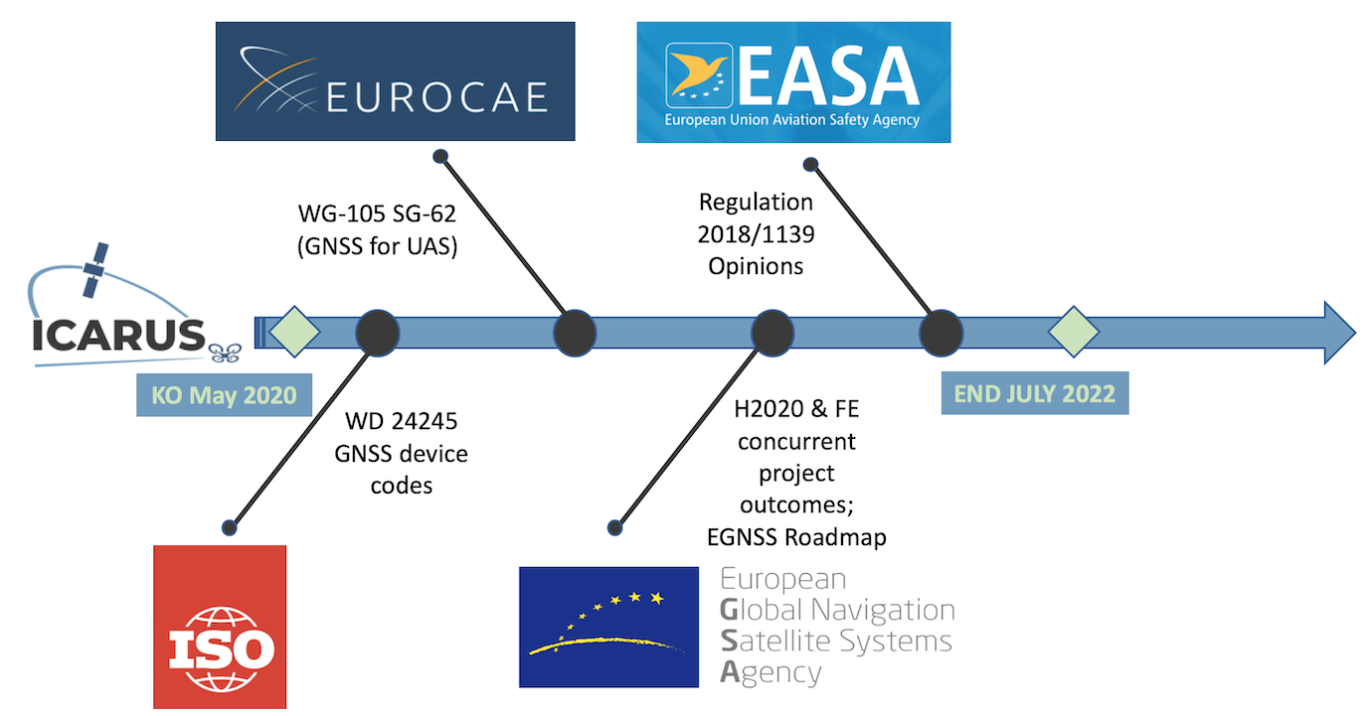
Figure 8 – Standardization and regulatory bodies roadmap

 |  | 
 |  | 
 |  | 

https://www.eurocontrol.int/publication/uas-atm-common-altitude-reference-system-cars
https://www.eurocontrol.int/project/concept-operations-european-utm-systems
https://amuledproject.eu/
https://corus-xuam.eu/about/
http://labyrinth2020.eu/
https://cordis.europa.eu/project/id/892928
https://gof2.eu/project/
https://www.gsa.europa.eu/r-d/h2020/introduction
https://www.gsa.europa.eu/asset-mapping-platform-emerging-countries-electrification
https://www.gsa.europa.eu/drones-and-egnss-low-airspace-urban-mobility
https://projectradius.info
https://5gdrones.eu
https://projectsugus.eu
https://www.eurocontrol.int/publication/uas-atm-common-altitude-reference-system-cars
https://www.eurocontrol.int/project/concept-operations-european-utm-systems
Objectives – 5G!Drones H2020 ICT-19-2019 5G-PPP 5GDrones Project
Supporting-UAV-Services-in-5G-Networks.pdf (5gdrones.eu)
D1.3-System-Architecture-Initial-Design.pdf (5gdrones.eu)
D4.1 “Design and architecture of the ICARUS system & services”

